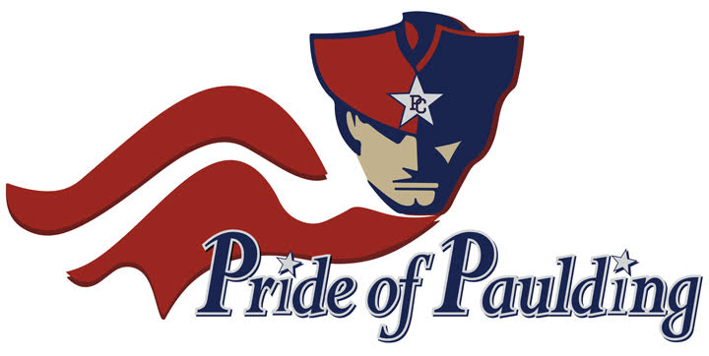
Paulding County High School Band Boosters, Inc.
PO Box 1302
Dallas, GA 30132
www.prideofpaulding.com

“The Pride of Paulding” Band Sponsorship Opportunities

“The Pride of Paulding” PCHS Band Boosters, Inc. is qualified to receive tax deductible Donations, bequests, devices, and or transfer of gifts under section 170 of the Internal Revenue Code, as a designated 501 (c) (3) entity. EIN#: 35-2220026

Package #1: Friends of the “The Pride of Paulding”
Recognized as any gift between $50.00 - $99.00

Benefits: The name of the Donor (Company or Individual) will be displayed on the prideofpaulding.com website and on our Facebook page.

Package #2: Benefactor of the “The Pride of Paulding”
Recognized as any gift between $100.00 - $499.00
Benefits: Same as #1, In addition, each sponsoring Company or Individual will be recognized over the PA system at every home Football Game during the 2016 Season, as a Benefactor for the Band Program,

Package #3: Sterling Sponsor of the “The Pride of Paulding”
Recognized as any gift between $500.00 and $999.00.
Benefits: Same as #1 and #2, In addition, each sponsoring Company or Individual will have their own individual banner.

Package #4: Gold Sponsor of the “The Pride of Paulding”
Recognized as any Gift between $1,000.00 and $1,499.00

Benefits: Same as #1, #2, and #3. In addition, each sponsoring Company or Individual will have their Name / Logo displayed on the Band Trailer, which accompanies the Band at every Football Game, Concert, and Competition at which they participate during the 2016 Calendar Year. (The Name and /or Logo of the Sponsor will be displayed between the Wheel Base and the Front of the Trailer on both sides in a 1.5’ x 2’ space).

Package #5: Platinum Sponsor of the “The Pride of Paulding”
Recognized as any Gift between $1,500.00 or more…
Benefits: Same as #1, #2, #3, and #4 (Advertising space on the trailer would be displayed between the wheel well and the rear of the trailer in a (2’ x 4’ space) and in addition the Sponsorship will include 2 Tickets to each home game during the 2016 Football Season, and a DVD of the Half-Time Performance as a Memento.

Your support is much needed & appreciated!!! All funds are allocated to directly benefit all students within the marching band/concert band programs. Your inclusion to these programs allow each student to experience the Arts and express their Passion of Music.

Sincerely,

Paulding County High School Band Boosters, Inc.

Paulding County High School Band Boosters, Inc.
PO Box 1302
Dallas, GA 30132
www.prideofpaulding.com

------------------------------------------------------------------------------------------------------------------------------------------------------------------

“The Pride of Paulding” Sponsorship Commitment Form
(please print and return this form)

Sponsorship Package Selected: _________________________________________

Method of Payment: __________________________________________________

Name of Sponsor/Donor: ______________________________________________

Address: ___________________________________________________________

City, State, Zip: _____________________________________________________

E-mail address: ______________________________________________________

Telephone Number: __________________________________________________

Primary Contact Name: _______________________________________________

Signature: __________________________________________________________

Date: ______________________________________________________________

All donations are due at the time of commitment.
If there is a logo involved, please e-mail your Preferred Logo in JPEG format to the following address: PCHSBB@gmail.com

